Applicant Details

Owner Agent of the Owner

Applicant / Company / Authority
Postal Address
Suburb |  |  | State |  | Postcode
Contact Name
Email |  |  |  |  | Mobile

Site Address
Application Details Please select the type of application you are making and fill in the description
Crane / Lifting Device | Please state below the Type of Crane / Lifting Device

Road Occupation | Please state below the Purpose of the Road Occupation
Details of Work

I hereby make application for a Local Law Road Occupation Permit for the following:

Occupation Location
Description of Building Work

Start Date |  |  | End Date
Start Time |  | am / pm | End Time |  | am / pm
Area of Public Space Occupied (m²) |  |  | Number of Days
Oversize, Overmass or Special Purpose Vehicles
Are you intending to use an Oversize, Overmass or Special Purpose Vehicle?
Yes | No
The permit holder must ensure that if an Oversize, Overmass or Special Purpose Vehicle (as defined under the Heavy Vehicle National Law Act 2012) is used on a Council Road, whilst enjoying the benefit of this local law permit, that a heavy vehicle permit from the relevant Road Authority (VicRoads) must also be obtained.

Accompanying Documents

Site Plan attached | Yes
Traffic Management Plan attached | Yes
Public Liability Insurance current certificate attached | Yes

Declaration by Applicant
To my knowledge all necessary building and/or planning permits have been obtained.
Site Plan included with application
Request invoice for payment of fees, to be issued on receipt of your application.

Signature of Applicant |  | Date
Print Name
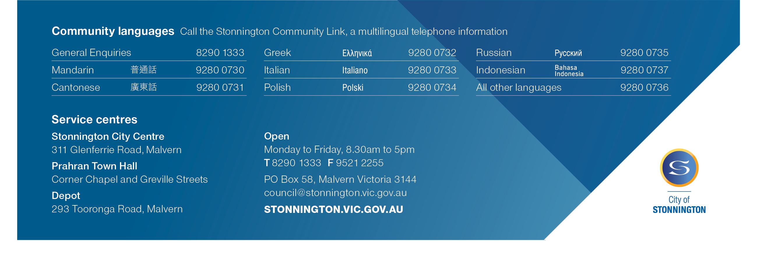
Privacy Statement: Personal information required on this form is for processing the Local Law Permit Application and will only be used by the Council for that purpose or a directly related purpose. After lodging the application, the applicant may obtain access to the information supplied and may amend the information. Requests for access may be made to Council’s Privacy Officer (Council general phone number 8290 1333).

PLAN TO ACCOMPANY APPLICATION FOR PERMIT
Location of Council land and area of closure, occupation or use
Details required on plan
- Street: road, highway, carriageway, lane, footway, footpath, square, court, alley, right of way and any part of a road reserve.
- Nearest street intersection
- Any street furniture, parking signs, bins, power poles, pits, bus stops/shelters, etc
- Distance in metres remaining for pedestrians and/or cars whilst works are in place.
A minimum of 1.5m for pedestrians and 3m for cars must be maintained at all times.
North

