Part A | Applicant Details Complete and Circle as appropriate
I / We
Applicant Name

Intend on referring a building permit application for Council Consent and Report for
Property Address
Suburb |  | State |  | Postcode

To Stonnington City Council to vary the requirements of Part 5 of the Building Regulations 2018 to allow:
Description of Proposal

Those parts of the building which do not meet the requirements of Part 5 of the Building Regulations 2018 include:
Short Description of Non-Complying works

The proposed works are clearly highlighted on the attached plans:
List drawing numbers
1
2
3
4
Part B | Affected Property Owner
I / We
Owner Name(s)

As Owner(s) of
Unit |  | Street Number |  | Street Name
Suburb |  |  |  |  | State |  | Postcode

Phone | (m) | (w)
Email

Part B continued overleaf…

Part B | Affected Property Owner (continued)
Have sighted the above listed drawings and understand that the proposal does not comply with the minimum siting requirement(s) of the Building Regulations 2018 but offer no comment in regard to the proposal.
NB: Affected owner/s must sign and date plans to be submitted in association with this form.

OR

Wish to comment that the proposal will affect me / us in the following ways

Comments attached as to the way in which you will be affected | Yes | No
Number of pages attached
Signatures
Signature of Applicant |  | Date
Print Name
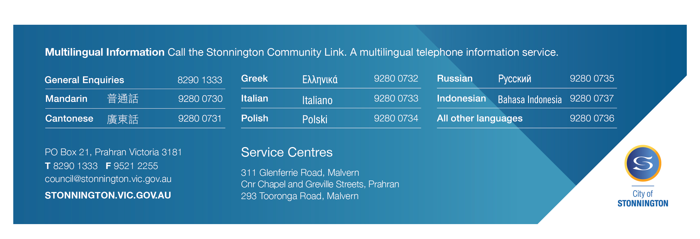
Signature of Applicant |  | Date
Print Name

Signature of Owner |  | Date
Print Name

Signature of Owner |  | Date
Print Name

Signature |  | Date
Print Name

Privacy Statement: Personal information required on this form is for processing the Local Law Permit Application and will only be used by the Council for that purpose or a directly related purpose. After lodging the application, the applicant may obtain access to the information supplied and may amend the information. Requests for access may be made to Council’s Privacy Officer (Council general phone number 8290 1333)

